HTML Block and Inline Elements

📘 Definition
# Source: AI Source: Provided by: [Data Path: Persons Table -> ID Column: 1, Name_En Column: Motasem Essam] -> From: [ChatGPT] on [5/6/2026]
HTML elements are generally divided into two categories:
- Block elements
- Inline elements
They behave differently in webpage layout.

🧠 Main Difference
# Source: AI Source: Provided by: [Data Path: Persons Table -> ID Column: 1, Name_En Column: Motasem Essam] -> From: [ChatGPT] on [5/6/2026]
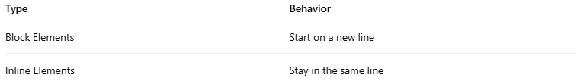
Type | Behavior
Block Elements | Start on a new line
Inline Elements | Stay in the same line

⚖️ Block vs Inline Comparison
# Source: AI Source: Provided by: [Data Path: Persons Table -> ID Column: 1, Name_En Column: Motasem Essam] -> From: [ChatGPT] on [5/6/2026]
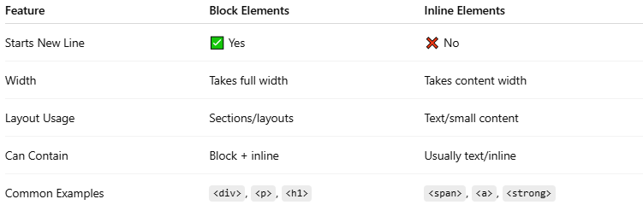
Feature | Block Elements | Inline Elements
Starts New Line | ✅ Yes | ❌ No
Width | Takes full width | Takes content width
Layout Usage | Sections/layouts | Text/small content
Can Contain | Block + inline | Usually text/inline
Common Examples | <div>, <p>, <h1> | <span>, <a>, <strong>

📦 Block Elements

📖 Description
# Source: AI Source: Provided by: [Data Path: Persons Table -> ID Column: 1, Name_En Column: Motasem Essam] -> From: [ChatGPT] on [5/6/2026]
Block elements:
- always start on a new line
- take full available width
- create page sections

🧩 Common Block Elements
# Source: AI Source: Provided by: [Data Path: Persons Table -> ID Column: 1, Name_En Column: Motasem Essam] -> From: [ChatGPT] on [5/6/2026]
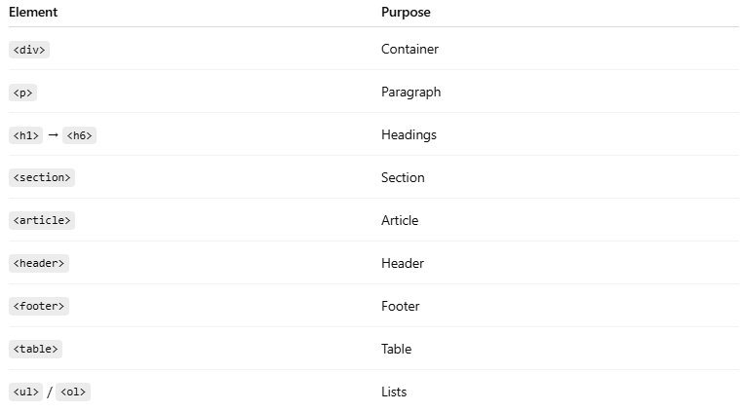
Element | Purpose
<div> | Container
<p> | Paragraph
<h1> → <h6> | Headings
<section> | Section
<article> | Article
<header> | Header
<footer> | Footer
<table> | Table
<ul> / <ol> | Lists

💻 Example:
# Source: AI Source: Provided by: [Data Path: Persons Table -> ID Column: 1, Name_En Column: Motasem Essam] -> From: [ChatGPT] on [5/6/2026]
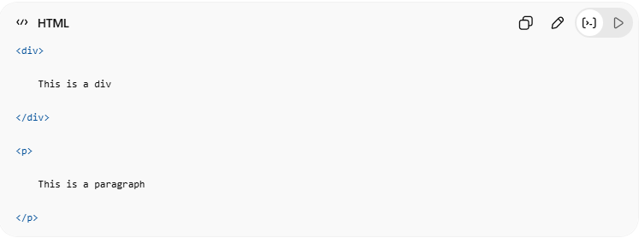
<div>
This is a div
</div>
<p>
This is a paragraph
</p>
👉 Each element starts on a new line

🔤 Inline Elements

📖 Description
# Source: AI Source: Provided by: [Data Path: Persons Table -> ID Column: 1, Name_En Column: Motasem Essam] -> From: [ChatGPT] on [5/6/2026]
Inline elements:
- stay in the same line
- only take needed width
- used inside text

🧩 Common Inline Elements
# Source: AI Source: Provided by: [Data Path: Persons Table -> ID Column: 1, Name_En Column: Motasem Essam] -> From: [ChatGPT] on [5/6/2026]
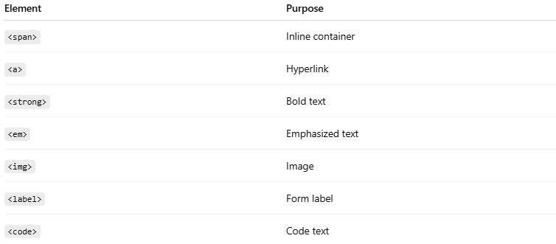
Element | Purpose
<span> | Inline container
<a> | Hyperlink
<strong> | Bold text
<em> | Emphasized text
<img> | Image
<label> | Form label
<code> | Code text

💻 Example:
# Source: AI Source: Provided by: [Data Path: Persons Table -> ID Column: 1, Name_En Column: Motasem Essam] -> From: [ChatGPT] on [5/6/2026]
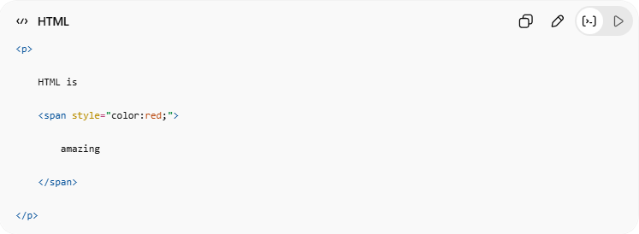
<p>
HTML is
<span style="color:red;">
amazing
</span>
</p>
👉 <span> stays inside the same line

🎯 Visual Example
# Source: AI Source: Provided by: [Data Path: Persons Table -> ID Column: 1, Name_En Column: Motasem Essam] -> From: [ChatGPT] on [5/6/2026]
💻 Example:
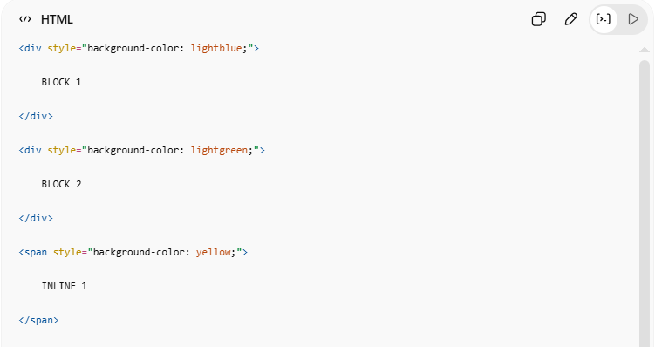
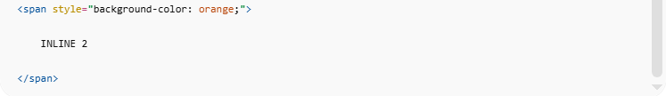
<div style="background-color: lightblue;">
BLOCK 1
</div>
<div style="background-color: lightgreen;">
BLOCK 2
</div>
<span style="background-color: yellow;">
INLINE 1
</span>
<span style="background-color: orange;">
INLINE 2
</span>
👉 Block elements appear vertically
👉 Inline elements appear horizontally

💻 Example

Full Example
# Source: AI Source: Provided by: [Data Path: Persons Table -> ID Column: 1, Name_En Column: Motasem Essam] -> From: [ChatGPT] on [5/6/2026]
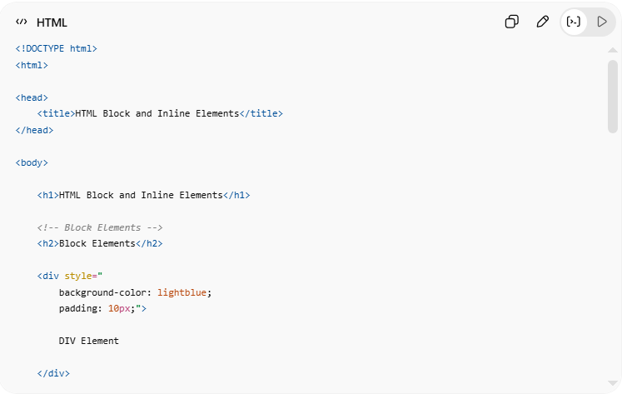
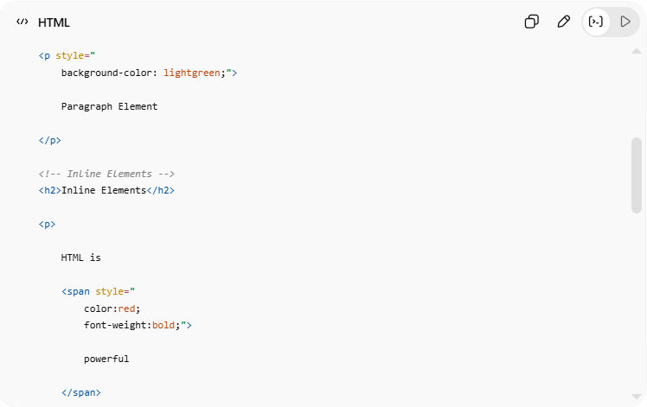
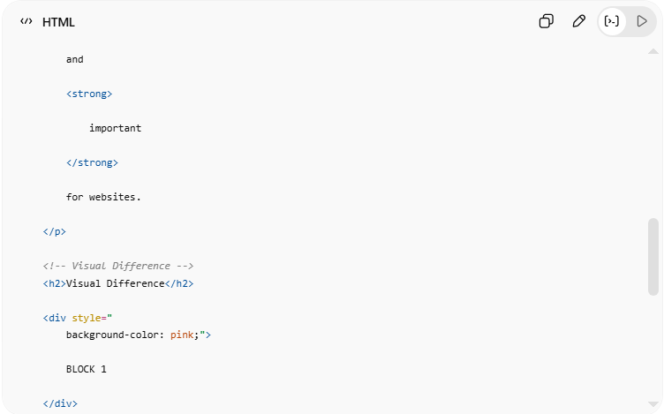
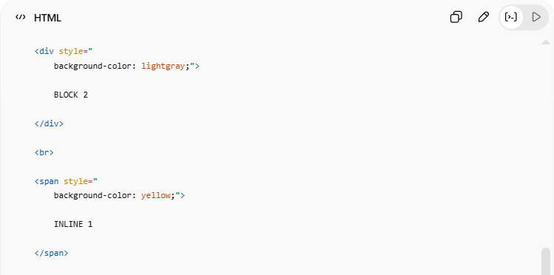
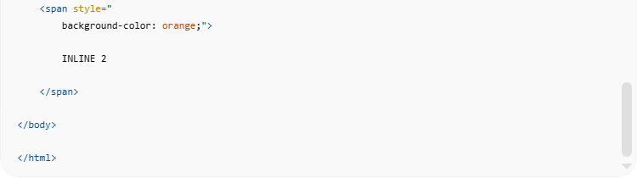
<!DOCTYPE html>
<html>
<head>
<title>HTML Block and Inline Elements</title>
</head>
<body>
<h1>HTML Block and Inline Elements</h1>
<!-- Block Elements -->
<h2>Block Elements</h2>
<div style="
background-color: lightblue;
padding: 10px;">
DIV Element
</div>
<p style="
background-color: lightgreen;">
Paragraph Element
</p>
<!-- Inline Elements -->
<h2>Inline Elements</h2>
<p>
HTML is
<span style="
color:red;
font-weight:bold;">
powerful
</span>
and
<strong>
important
</strong>
for websites.
</p>
<!-- Visual Difference -->
<h2>Visual Difference</h2>
<div style="
background-color: pink;">
BLOCK 1
</div>
<div style="
background-color: lightgray;">
BLOCK 2
</div>
<br>
<span style="
background-color: yellow;">
INLINE 1
</span>
<span style="
background-color: orange;">
INLINE 2
</span>
</body>
</html>

Real Example
# Source: ScreenShot Source: Provided by: [Persons Table -> ID Column: 1, Name_En Column: Motasem Essam] -> Tool: [Automation Table -> ID Column: 16, Name_En Column: Screen Capture] -> From [Operating System: Windows] on [5/6/2026]
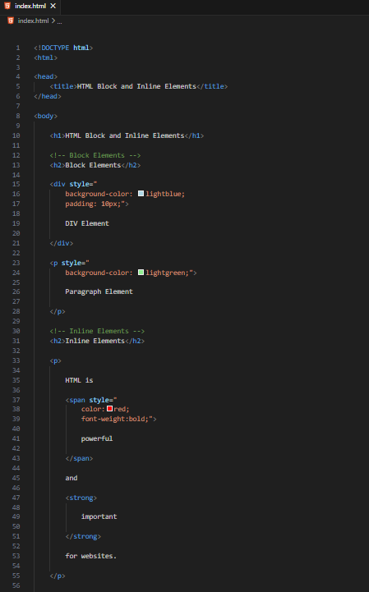
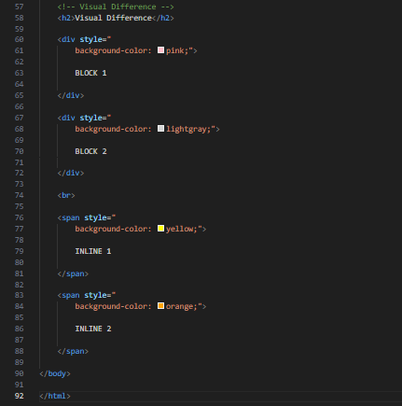
<!DOCTYPE html>
<html>

<head>
<title>HTML Block and Inline Elements</title>
</head>

<body>

<h1>HTML Block and Inline Elements</h1>

<!-- Block Elements -->
<h2>Block Elements</h2>

<div style="
background-color: lightblue;
padding: 10px;">

DIV Element

</div>

<p style="
background-color: lightgreen;">

Paragraph Element

</p>

<!-- Inline Elements -->
<h2>Inline Elements</h2>

<p>

HTML is

<span style="
color:red;
font-weight:bold;">

powerful

</span>

and

<strong>

important

</strong>

for websites.

</p>

<!-- Visual Difference -->
<h2>Visual Difference</h2>

<div style="
background-color: pink;">

BLOCK 1

</div>

<div style="
background-color: lightgray;">

BLOCK 2

</div>

<br>

<span style="
background-color: yellow;">

INLINE 1

</span>

<span style="
background-color: orange;">

INLINE 2

</span>

</body>

</html>
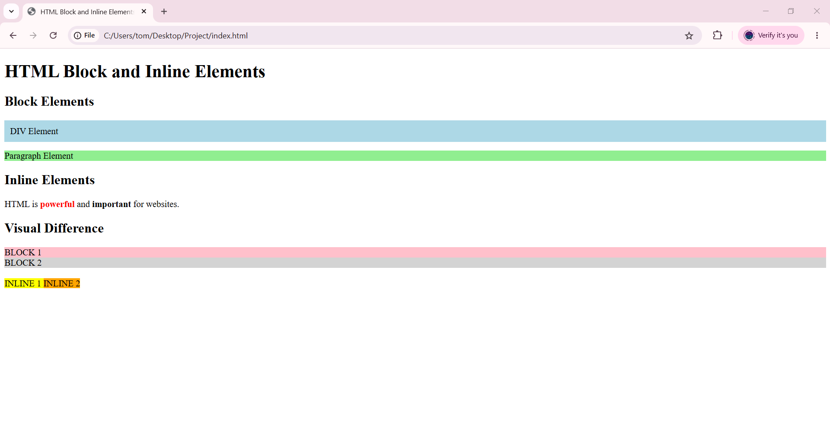

🧪 What You Can Test
# Source: AI Source: Provided by: [Data Path: Persons Table -> ID Column: 1, Name_En Column: Motasem Essam] -> From: [ChatGPT] on [5/6/2026]
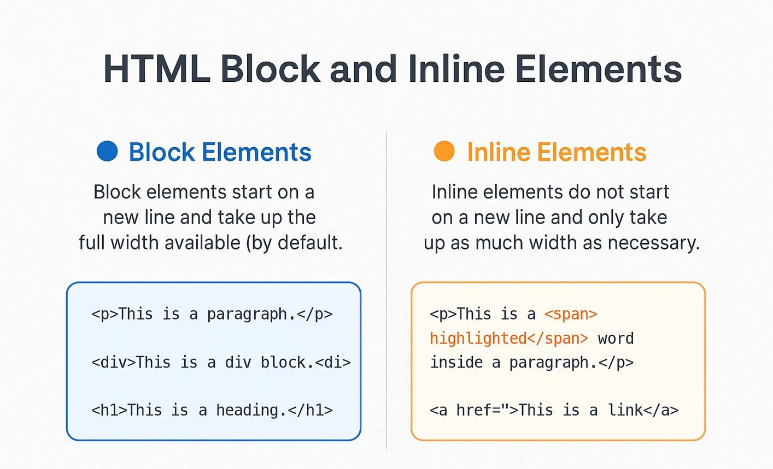
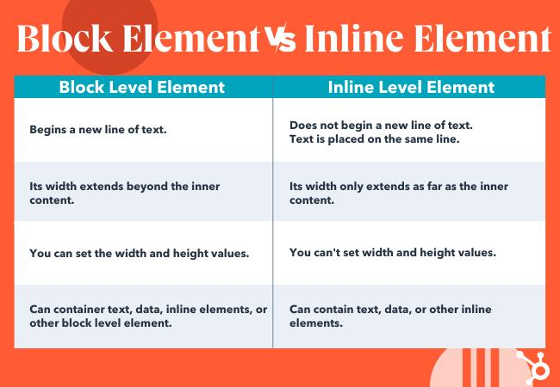
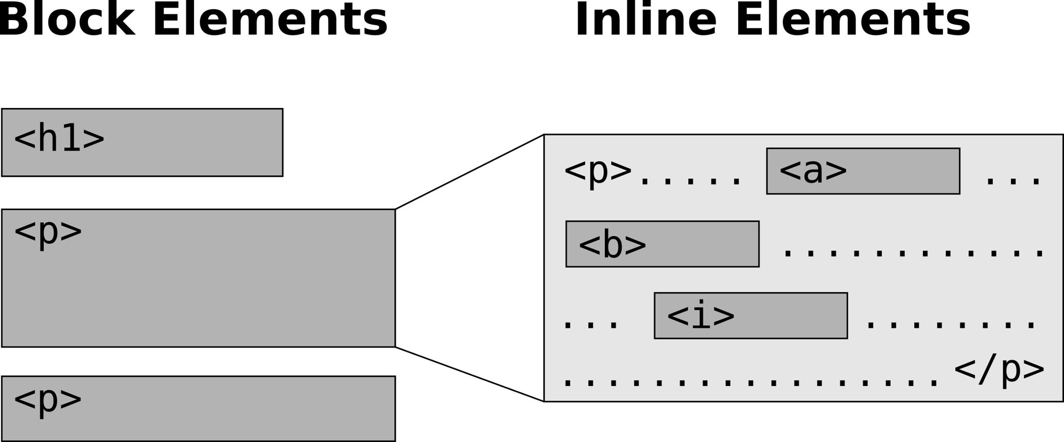
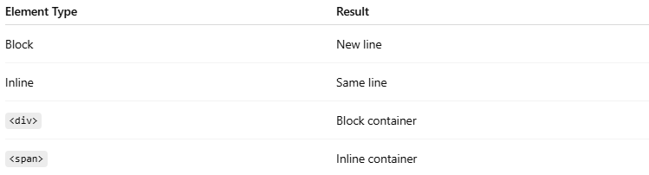
Element Type | Result
Block | New line
Inline | Same line
<div> | Block container
<span> | Inline container

⚠️ Important Notes

✅ Use block elements for page structure
# Source: AI Source: Provided by: [Data Path: Persons Table -> ID Column: 1, Name_En Column: Motasem Essam] -> From: [ChatGPT] on [5/6/2026]
👉 Layouts and sections

✅ Use inline elements for text styling
# Source: AI Source: Provided by: [Data Path: Persons Table -> ID Column: 1, Name_En Column: Motasem Essam] -> From: [ChatGPT] on [5/6/2026]
👉 Small content changes

❌ Don’t use inline elements for large layouts
# Source: AI Source: Provided by: [Data Path: Persons Table -> ID Column: 1, Name_En Column: Motasem Essam] -> From: [ChatGPT] on [5/6/2026]
👉 Not designed for structure

✅ CSS can change element behavior
# Source: AI Source: Provided by: [Data Path: Persons Table -> ID Column: 1, Name_En Column: Motasem Essam] -> From: [ChatGPT] on [5/6/2026]
👉 Example:
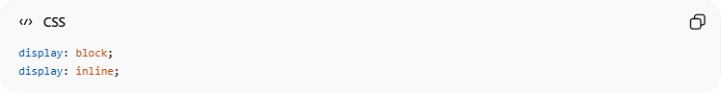
display: block;
display: inline;

🚀 In short:
# Source: AI Source: Provided by: [Data Path: Persons Table -> ID Column: 1, Name_En Column: Motasem Essam] -> From: [ChatGPT] on [5/6/2026]
- 📦 Block elements start on new lines and take full width
- 🔤 Inline elements stay within the same line
- Both are essential for webpage structure and styling

